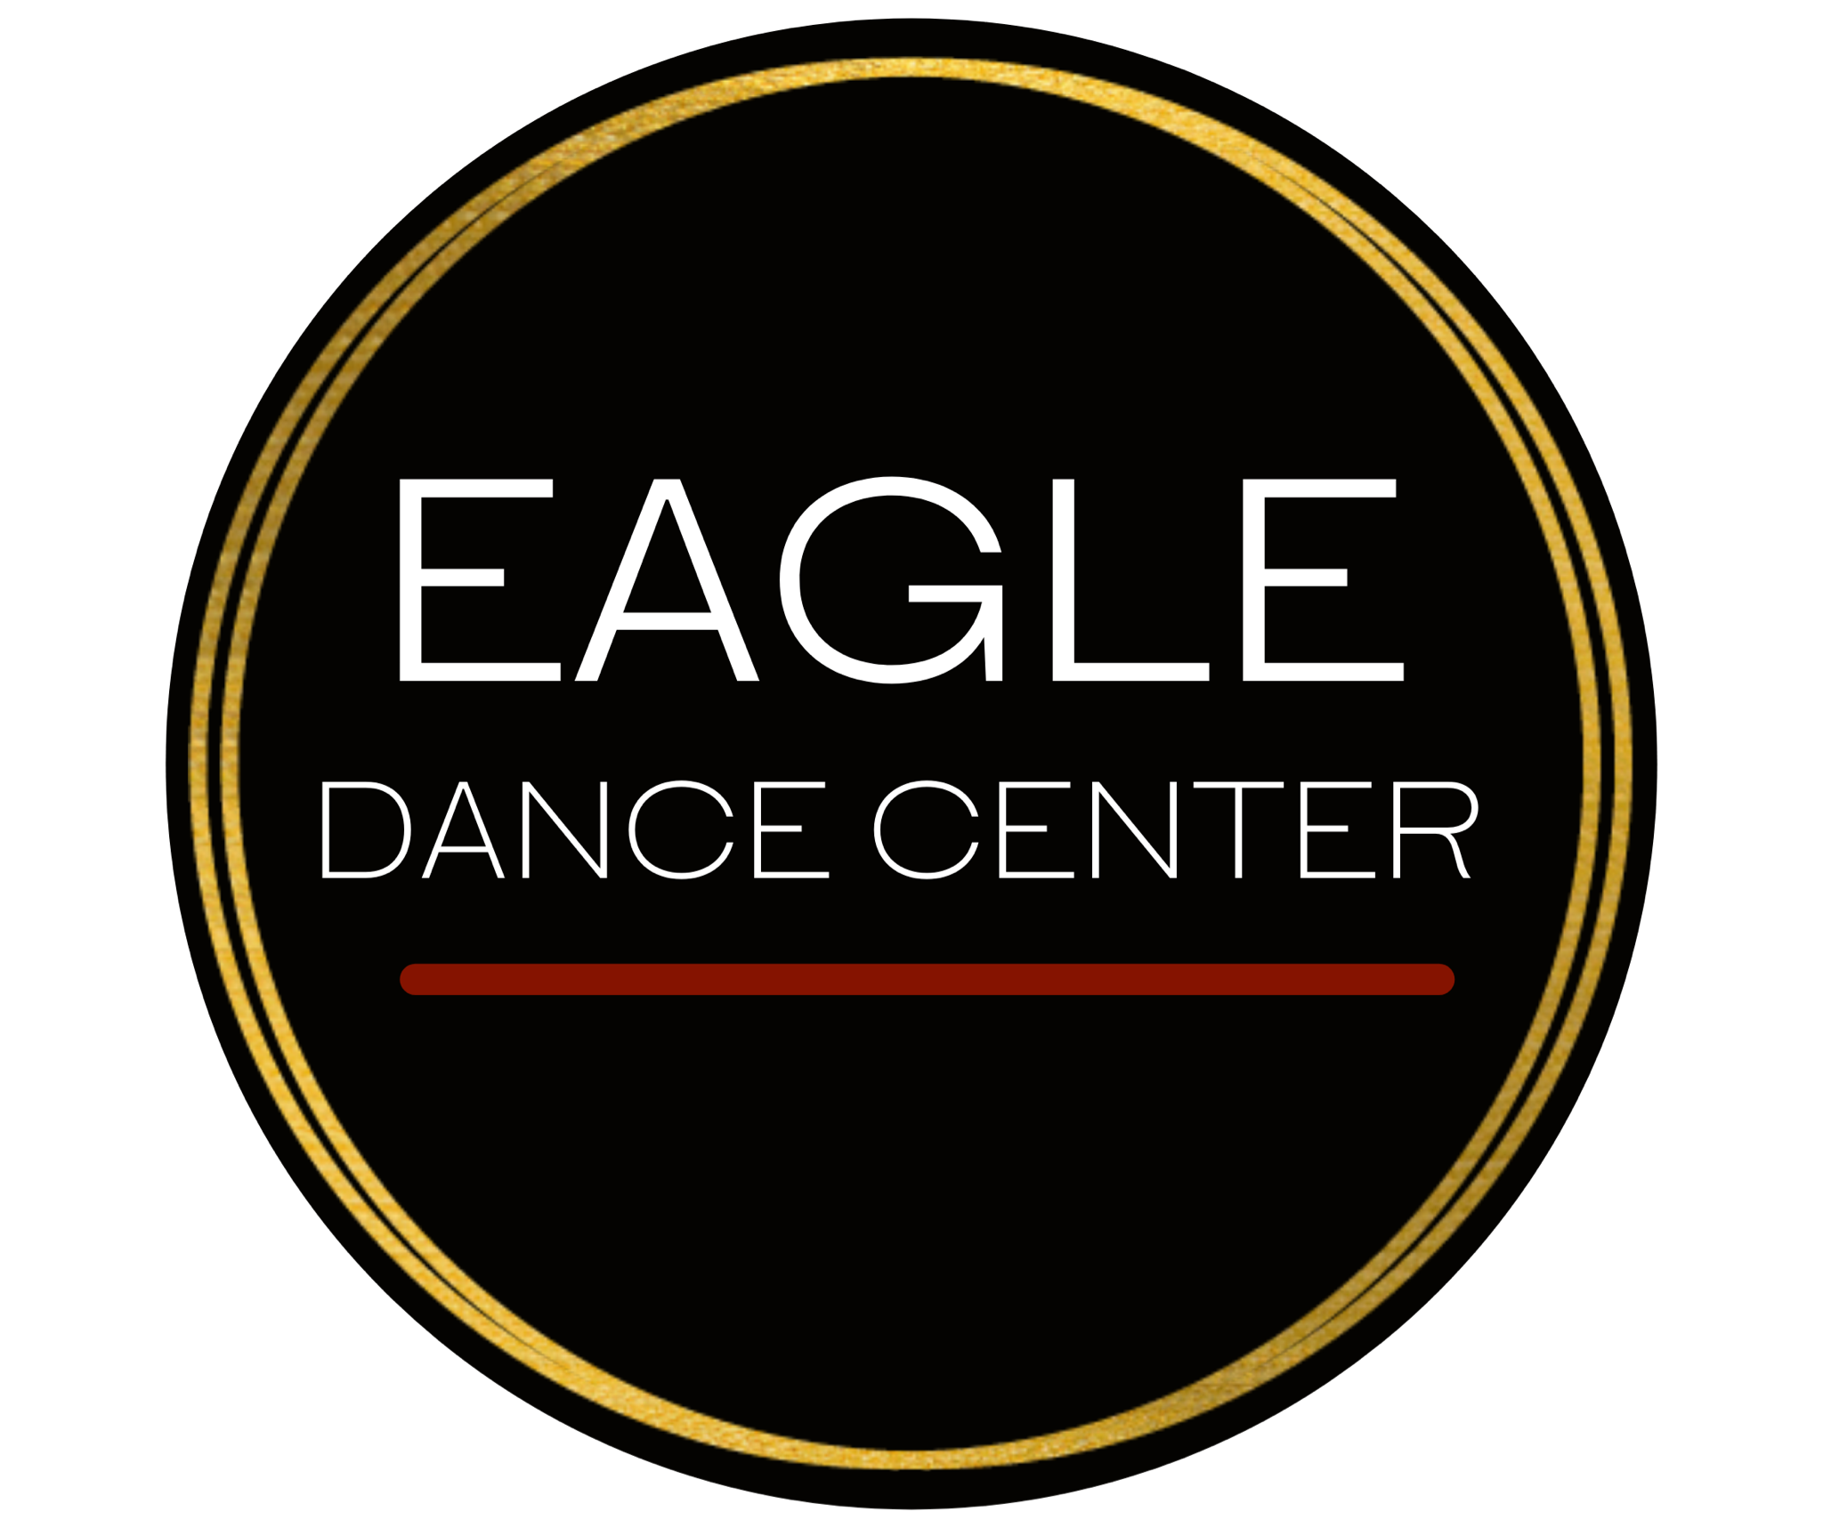
Dress Code/Attire Policy
All classes: Hair is to be secured completely back and out of the face in a bun, ponytail, or braid. We recommend avoiding large hair bows/hair barrettes along with high ponytails/buns for tumbling due to activity in class.
Dance classes: Attire may be purchased through our website or in our boutique, tights and shoes must be purchased through our website or in our boutique to ensure consistency in color and style for recital.
Tumbling classes: Shoes and attire can be purchased through our boutique, but is not required.
CLASS | ATTIRE | FOOTWEAR | OPTIONAL
All Tumbling Classes (Tiny Tumbling, Tumbling 1/2/3, MS/HS Tumbling, Open Gym, Superhero Tumbling) | Tight fitting athletic clothing; leotard, athletic tank top, athletic leggings/shorts, athletic sports bra. | Barefoot, dance shoes, or cheerleading/athletic shoes, depending on desired execution of skills. No socks. | -
Cheerleading  (Grades 1-6) | Tight fitting athletic clothing; leotard, athletic tank top, athletic leggings/shorts, athletic sports bra. | Cheerleading/athletic shoes for indoor use ONLY. | -
Creative Movement  (Ages 3-4) | Any color.  Girls: Leotard, pink or tan tights. Boys: Dance shirt, athletic shorts/pants. | Pink (boys, black) leather full sole ballet shoe (ballet classes). Black Velcro student tap shoes (tap classes). | Dance skirt, leggings, crop sweater, dance shorts, leg warmers, leggings.
Pom 1, 2, 3  (Ages 6 - 12th Grade) | Tight fitting athletic clothing; leotard, athletic tank top, sports bra, athletic shorts, leggings. | Revolution Brand tan leather jazz boots. | -
Ballet 1  (Ages 5-7) | Light pink or black.  Girls: Leotard, pink or tan tights. Boys: Dance shirt, athletic shorts/pants. | Revolution Brand pink (boys, black) leather full sole ballet shoe. | Black or Light Pink: dance skirt, crop sweater, dance shorts, leg warmers. No leggings.
Jazz 1  (Ages 5-7) | Light pink or black.  Girls: Leotard, pink or tan tights. Boys: Dance shirt, athletic shorts/pants. | Revolution Brand tan leather jazz boots. | Black or Light Pink: Dance skirt, crop sweater, dance shorts, leggings, leg warmers.
Tap 1  (Ages 5-7) | Light pink or black.  Girls: Leotard, pink or tan tights. Boys: Dance shirt, athletic shorts/pants. | Revolution Brand black velcro student tap shoe. | Black or Light Pink: Dance skirt, crop sweater, dance shorts, leggings, leg warmers.
Hip Hop 1 (Funky Jazz: Intro to Hip Hop)  (Ages 5-7) | Athletic clothing that allows freedom of movement or leotard. NO JEANS. | Revolution Brand tan leather jazz boots. | -
Musical Theater 1&2  (Ages 6-10) | Light pink or black.  Girls: Leotard, pink or tan tights. Boys: Dance shirt, athletic shorts/pants. | Revolution Brand tan leather jazz boots. | Black, light pink, or lavender: Dance skirt, crop sweater, dance shorts, leg warmers.
Ballet 2  (Ages 8-10) | Light purple or black.  Girls: Leotard, pink or tan tights. Boys: Dance shirt, athletic shorts/pants. | Revolution Brand pink (boys, black) leather full sole ballet shoe. | Black or light purple: dance skirt, crop sweater, dance shorts, leg warmers. No leggings.
Jazz 2  (Ages 8-10) | Light purple or black.  Girls: Leotard, pink or tan tights. Boys: Dance shirt, athletic shorts/pants. | Revolution Brand tan leather jazz boots. | Black or light purple: Dance skirt, crop sweater, dance shorts, leggings, leg warmers.
Tap 2  (Ages 8-10) | Light purple or black.  Girls: Leotard, pink or tan tights. Boys: Dance shirt, athletic shorts/pants. | Revolution Brand black buckle U-shell tap shoe. | Black or light purple: Dance skirt, crop sweater, dance shorts, leggings, leg warmers.
Hip Hop 2, 3/4, 5  (Ages 8-12th Grade) | Athletic clothing that allows freedom of movement. NO JEANS. | Black and white shoes for indoor use ONLY. Should be at least 75% black in color, only WHITE in additional color for consistency in recital. | -
Ballet 3/4  (Ages 11 - 8th Grade) | Light blue or black.  Girls: Leotard, pink or tan tights. Boys: Dance shirt, athletic shorts/pants. | Revolution Brand pink (boys, black) leather split sole ballet shoe. | Black or Light Blue: Dance skirt, crop sweater, dance shorts, leg warmers. No leggings.
Jazz 3/4  (Ages 11- 8th Grade) | Light blue or black.  Girls: Leotard, pink or tan tights. Boys: Dance shirt, athletic shorts/pants. | Revolution Brand tan leather jazz boots. | Black or Light Blue: Dance skirt, crop sweater, dance shorts, leggings, leg warmers.
Tap 3/4  (Ages 11 - 8th Grade) | Light blue or black.  Girls: Leotard, pink or tan tights. Boys: Dance shirt, athletic shorts/pants. | Revolution Brand black lace-up tap shoe. | Black or Light Blue: Dance skirt, crop sweater, dance shorts, leggings, leg warmers.
Contemporary 1/2  (Ages 11 - 8th Grade) | Light blue, light purple, or black.  Girls: Leotard, pink or tan tights. Boys: Dance shirt, athletic shorts/pants. | Leather or canvas half-soles. | Black or Light Blue: Dance skirt, crop sweater, dance shorts, leg warmers.
Leaps & Turns 1  (Ages 11 - 8th Grade) | Light blue or black.  Girls: Leotard, pink or tan tights. Boys: Dance shirt, athletic shorts/pants. | Choice of ballet shoe, jazz boot, or half sole. | Black or Light Blue: Dance skirt, crop sweater, dance shorts, leg warmers.
Musical Theatre 3/4  (Ages 11-12th Grade) | Light blue, red or black.  Girls: Leotard, pink or tan tights. Boys: Dance shirt, athletic shorts/pants. | Revolution Brand tan leather jazz boots. WITH INSTRUCTOR CLEARANCE: 2” tan character shoes. | Black, light blue, or red: Dance skirt, crop sweater, dance shorts, leg warmers.

Ballet 5  (High School) | Red or black.  Girls: Leotard, pink or tan tights. Boys: Dance shirt, athletic shorts/pants. | Revolution Brand pink (boys, black) leather split sole ballet shoe. | Black or Red: Dance skirt, crop sweater, dance shorts, leg warmers. No leggings.
Jazz 5  (High School) | Red or black.  Girls: Leotard, pink or tan tights. Boys: Dance shirt, athletic shorts/pants. | Revolution Brand tan leather jazz boots. | Black or Red: Dance skirt, crop sweater, dance shorts, leggings, leg warmers.
Tap 5  (High School) | Red or black.  Girls: Leotard, pink or tan tights. Boys: Dance shirt, athletic shorts/pants. | Black lace-up tap shoe. Revolution brand available through website, higher quality shoe may be individually ordered. | Black or Red: Dance skirt, crop sweater, dance shorts, leggings, leg warmers.
Contemporary 3  (High School) | Red or black.  Girls: Leotard, pink or tan tights. Boys: Dance shirt, athletic shorts/pants. | Leather or canvas half-soles. | Black or Red: Dance skirt, crop sweater, dance shorts, leg warmers.
Leaps & Turns 2  (High School) | Red or black.  Girls: Leotard, pink or tan tights. Boys: Dance shirt, athletic shorts/pants. | Choice of ballet shoe, jazz boot, or half sole. | Black or Red: Dance skirt, crop sweater, dance shorts, leg warmers.
Pointe  (By Instructor Discretion Only) | Light blue, red or black leotard, pink or tan tights. | Pointe shoe by professional fitting. | Black or Red: Dance skirt, crop sweater, dance shorts, leg warmers. No leggings.

